**Stage 4 – This is one of the dumbest things I’ve made today**

**RULES:** USPSA Competition Rules, Latest Edition **COURSE DESIGNER:** John Royer

|  |  |
| --- | --- |
| **START POSITION: See written stage briefing.** | |
| **STAGE PROCEDURE**  See written stage briefing. | **SCORING**  **SCORING:** Comstock 12 rounds.  **TARGETS:** There are 10 steel targets and 1 cardboard target.  **SCORED HITS:** 2 Best hits per carboard will be scored, steel must fall to score.  **START-STOP:**  Audible - Last shot  **PENALTIES:** Per USPSA Competition Rules |

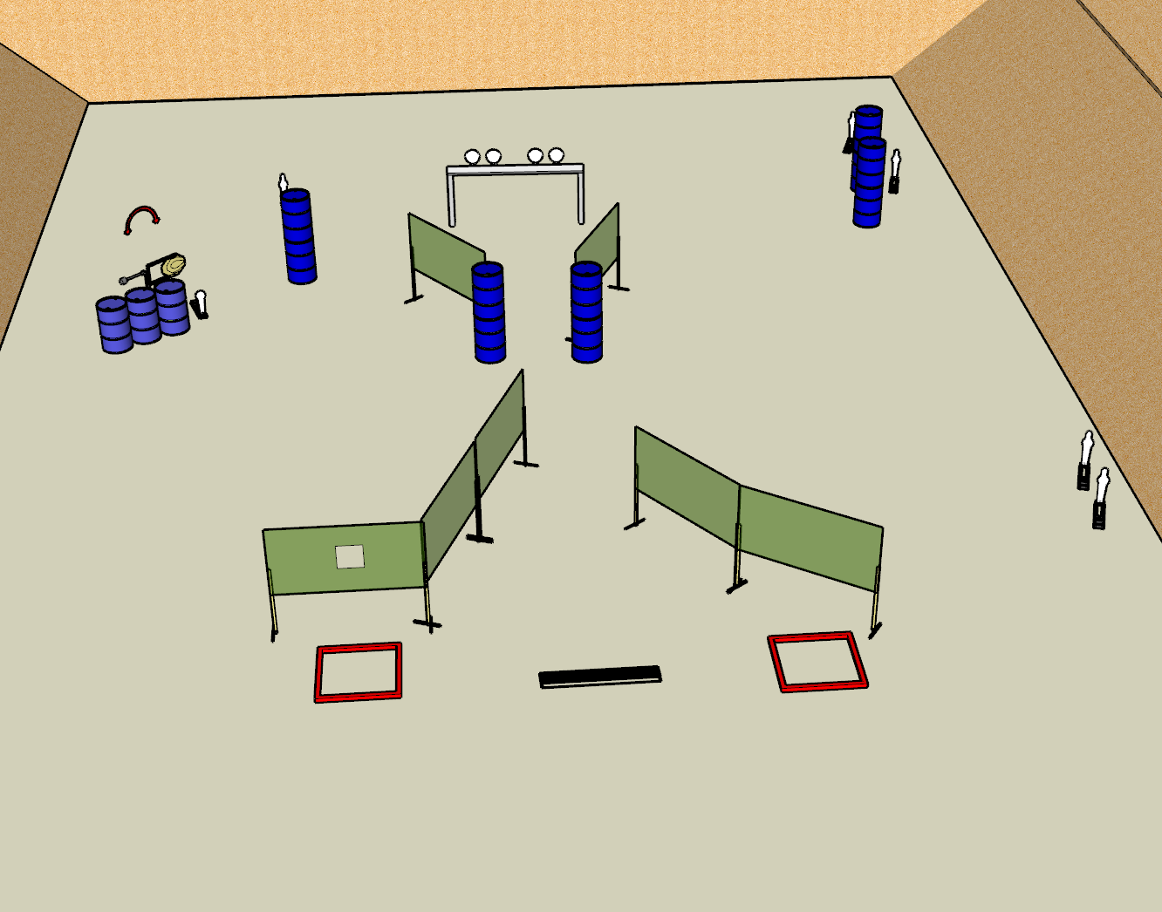

**Written Stage Briefing:**

**Stage 3 –** is a 12-round, 60 point, Comstock Medium Course. There are 10 steel targets and 1 cardboard. The best 2 hits per cardboard target will be scored. The steel targets must fall to score. The swinger is visible at rest.

**Start position** Standing anywhere completely outside the shooting area. Handgun is unloaded and holstered, wrists above shoulders. PCC is unloaded, muzzle pointed down range.

On the audible start signal, engage targets from within the shooting area.

**Setup Notes:**

Ensure plates from the plate rack are visible only from the balance beam and that there are 2 positions required for the plates.

Ensure the swinger is not visible prior to activation.